WIPRO Linux System Programming :

**DAY 1:-**

**TASK 1:-** COMPARISION BETWEEN SINGLE CORE, DUAL CORE, QUAD CORE, I5 & I7 PROCESSORS .

ANS:-

Single core, dual-core, quad-core, i5, and i7 processors refer to different types of central processing units (CPUs) commonly used in computers and other electronic devices.

**Single Core**: A single-core processor has only one processing unit or core. It can handle one instruction at a time, making it suitable for basic tasks like web browsing, word processing, and email.

**Dual-Core**: A dual-core processor contains two cores, allowing it to handle two instructions simultaneously. This enhances multitasking capabilities and performance compared to a single-core processor. Dual-core processors are suitable for moderate multitasking, multimedia tasks, and light gaming.

**Quad-Core**: A quad-core processor features four cores, enabling it to execute four instructions concurrently. Quad-core processors offer improved performance for multitasking, gaming, multimedia editing, and other demanding tasks compared to dual-core or single-core processors.

**i5 Processors**: Intel Core i5 processors are mid-range CPUs typically found in mainstream laptops and desktop computers. They offer a balance of performance and power efficiency, making them suitable for a wide range of tasks including multitasking, productivity applications, light gaming, and multimedia consumption. i5 processors usually come with either dual-core or quad-core configurations, depending on the specific m0odel and generation.

**i7 Processors**: Intel Core i7 processors are high-performance CPUs designed for demanding tasks such as gaming, content creation, video editing, and professional applications. They typically feature quad-core or higher core counts, along with advanced features like hyper-threading (simulating additional virtual cores), larger cache sizes, and higher clock speeds compared to i5 processors. i7 processors are often preferred by power users and enthusiasts seeking top-tier performance.

**DAY 2:-**

**Network or Network id 192**

**Host**

| **Name** | **First octet** | **Number of subnets** | **Number of hosts** | **Description** |
| --- | --- | --- | --- | --- |
| Class A | 1 to 127 | 126 | Approximately 16.7 million | Many hosts per network. |
| Class B | 128 to 191 | 16,384 | 65,536 | Many hosts per network. |
| Class C | 192 to 223 | Approximately 2.1 million | 254 | Many networks with fewer hosts per network. |
| Class D | 224 to 239 | n/a | n/a | Multicasting. |
| Class E | 240 to 254 | n/a | n/a | Experimental |

| **Reserved class** | **Range** | **Default subnet mask** | **Description** |
| --- | --- | --- | --- |
| Class A | 10.0.0.0 | 255.0.0.0 | Larger networks with many hosts. |
| Class B | 172.16.0.0 | 255.255.0.0 | Medium networks with a moderate number of hosts. |
| Class C | 192.168.0.0 | 255.255.255.0 | Smaller networks with fewer hosts. |

**Class A : N.H.H.H**

**Class B : N.N.H.H**

**Class C : N.N.N.H**

|  |  |  |
| --- | --- | --- |
| /1 128 | 0 | 0 0 |
| /2 192 | 0 | 0 0 |
| /3 224 | 0 | 0 0 |
| /4 240 | 0 | 0 0 |
| /5 248 | 0 | 0 0 |
| /6 252 | 0 | 0 0 |
| /7 254 | 0 | 0 0 |

|  |  |  |  |  |
| --- | --- | --- | --- | --- |
| /18 | 255 | 0 | 0 | 0 |
| /19 | 255 | 128 | 0 | 0 |
| /10 | 255 | 192 | 0 | 0 |
| /11 | 255 | 224 | 0 | 0 |
| /12 | 255 | 240 | 0 | 0 |
| /13 | 255 | 248 | 0 | 0 |
| /14 | 255 | 252 | 0 | 0 |
| /15 | 255 | 254 | 0 | 0 |
| /16 | 255 | 255 | 128 | 0 |
| /17 | 255 | 255 | 192 | 0 |
| /18 | 255 | 255 | 224 | 0 |
| /19 | 255 | 255 | 240 | 0 |
| /20 | 255 | 255 | 248 | 0 |
| /21 | 255 | 255 | 252 | 0 |
| /22 | 255 | 255 | 254 | 0 |
| /23 | 255 | 255 | 255 | 0 |
| /24 | 255 | 255 | 255 | 0 |
| /25 | 255 | 255 | 255 | 128 |
| /26 | 255 | 255 | 255 | 192 |
| /27 | 255 | 255 | 255 | 224 |
| /28 | 255 | 255 | 255 | 240 |
| /29 | 255 | 255 | 255 | 248 |
| /30 | 255 | 255 | 255 | 252 |
| /31 | 255 | 255 | 255 | 254 |
| /32 | 255 | 255 | 255 | 255 |

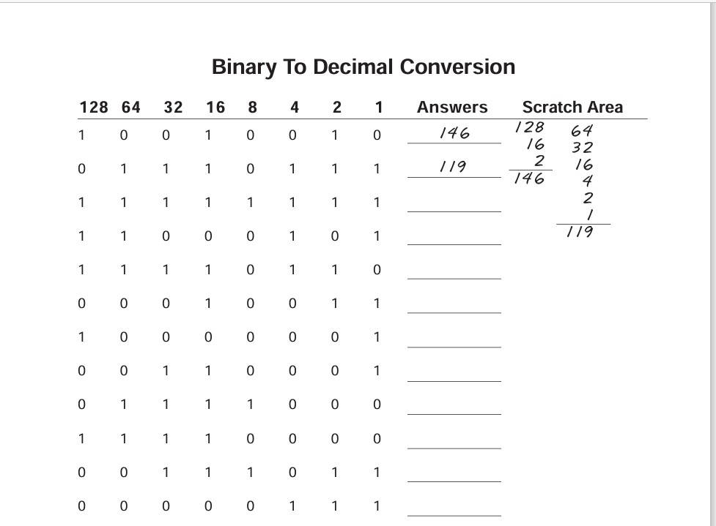

**Answer**

1. 146
2. 119
3. 255
4. 197
5. 246
6. 19
7. 129
8. 49
9. 120
10. 240
11. 59
12. 7

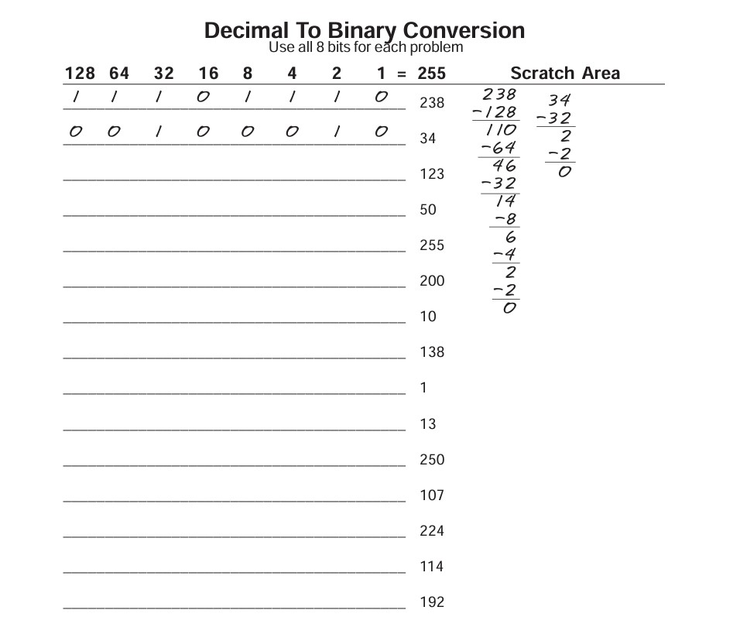

**Answer**

1. 1 1 1 0 1 1 1 0
2. 0 0 1 0 0 0 1 0
3. 0 1 1 1 1 0 1 1
4. 0 0 1 1 0 0 1 0
5. 1 1 1 1 1 1 1 1
6. 1 1 0 0 1 0 0 0
7. 0 0 0 0 1 0 1 0
8. 1 0 0 0 1 0 1 0
9. 0 0 0 0 0 0 0 1
10. 0 0 0 0 1 1 0 1
11. 1 1 1 1 1 0 1 0
12. 0 1 1 0 1 0 1 1
13. 1 1 1 0 0 0 0 0
14. 0 1 1 1 0 0 1 0
15. 1 1 0 0 0 0 0 0

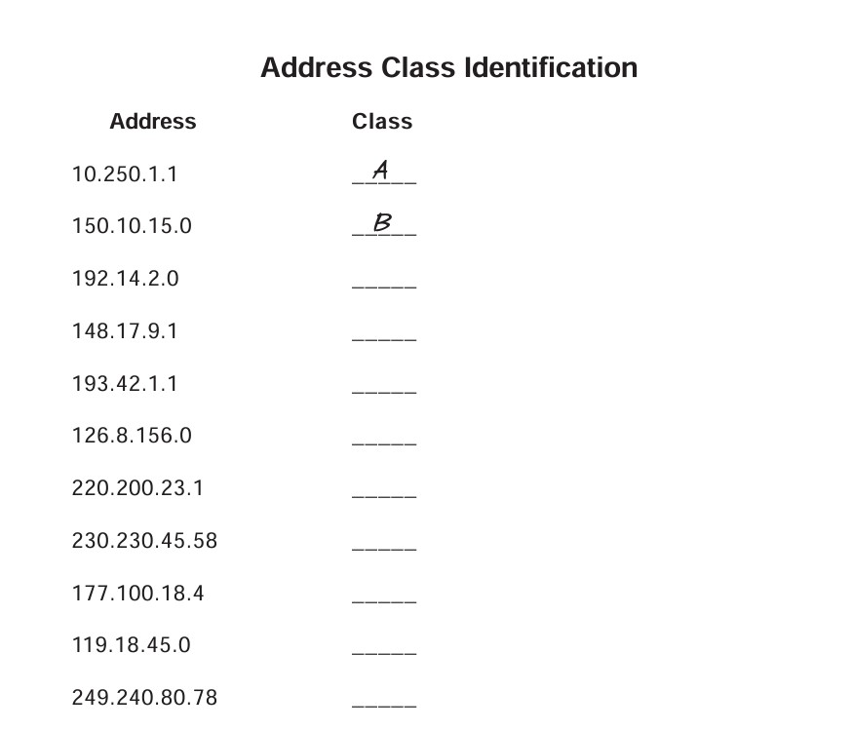

**Answer**

1. Class A
2. Class B
3. Class C
4. Class B
5. Class C
6. Class A
7. Class C
8. Class D
9. Class B
10. Class A
11. Class E

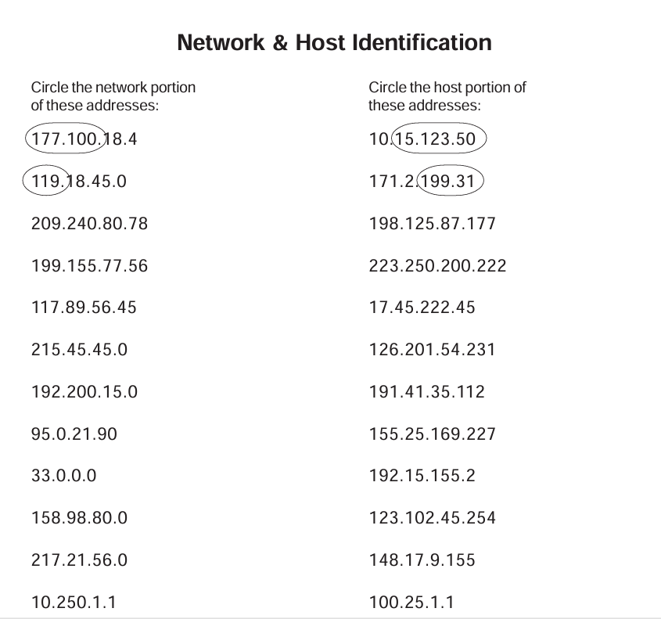

ANSWERS:-

209.240.80 177

199.155.77 222

117 45.222.45

215.45.45 201.54.231

192.200.15 35.112

95 169.227

33 2

158.98 102.45.245

217.21.56 9.155

10 25.1.1

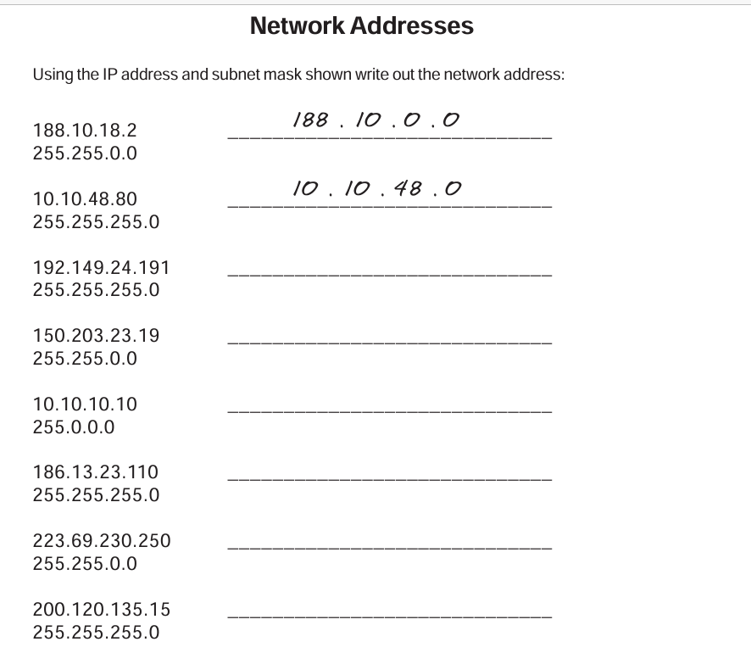

ANSWERS:-192.149.24.0

150.203.0.0

10.0.0.0

186.13.23.0

223.69.0.0

200.120.135.0

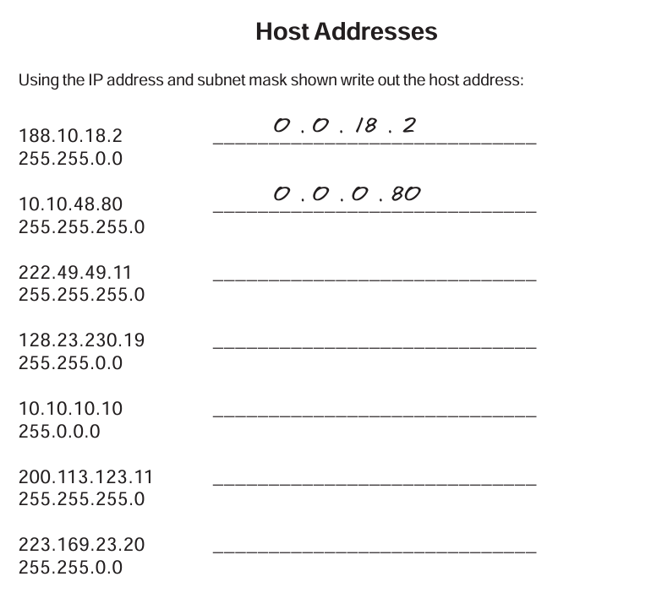

ANSWERS:-

0.0.0.11

0.0.230.19

0.10.10.10

0.0.0.11

0.0.23.20

Day:3 18/06/2024

1. Connect two routers
2. Connect Router with a Switch
3. Connect Router with PC
4. Connect PC with a switch

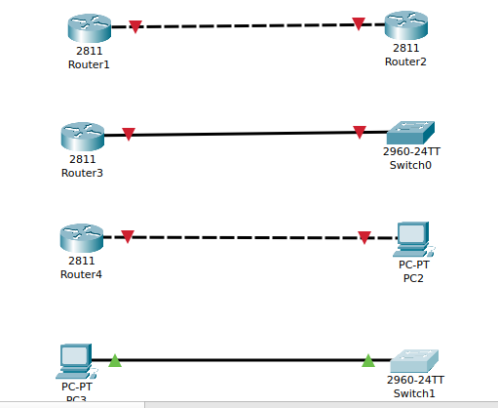

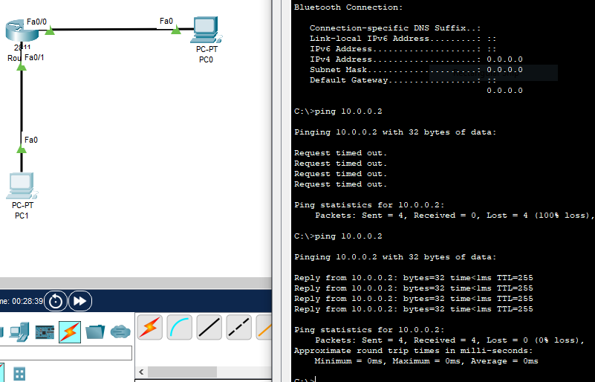

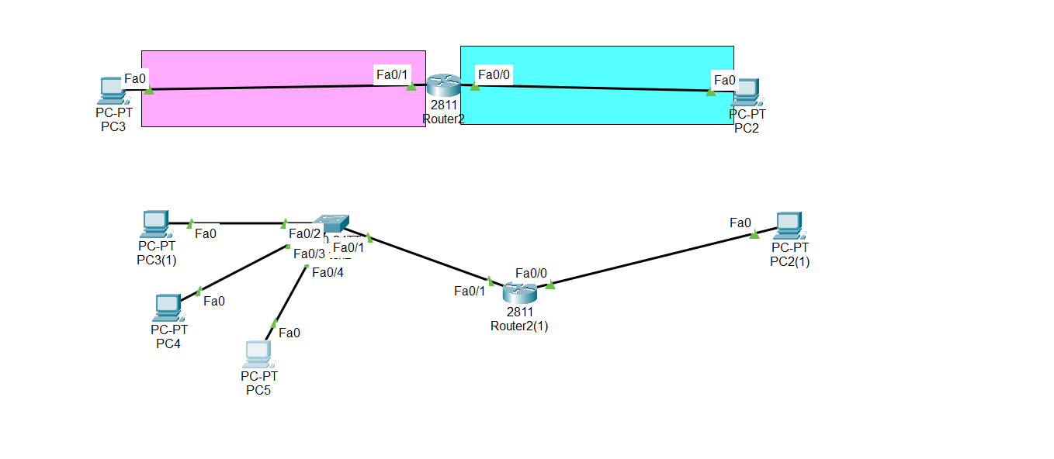

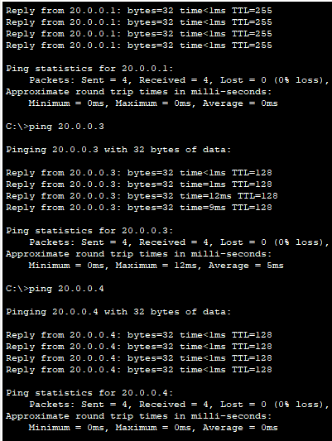

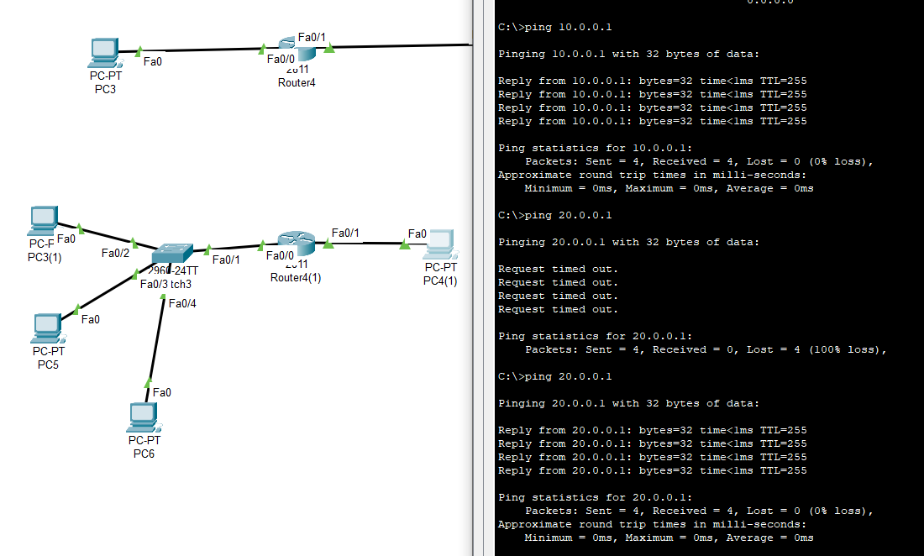

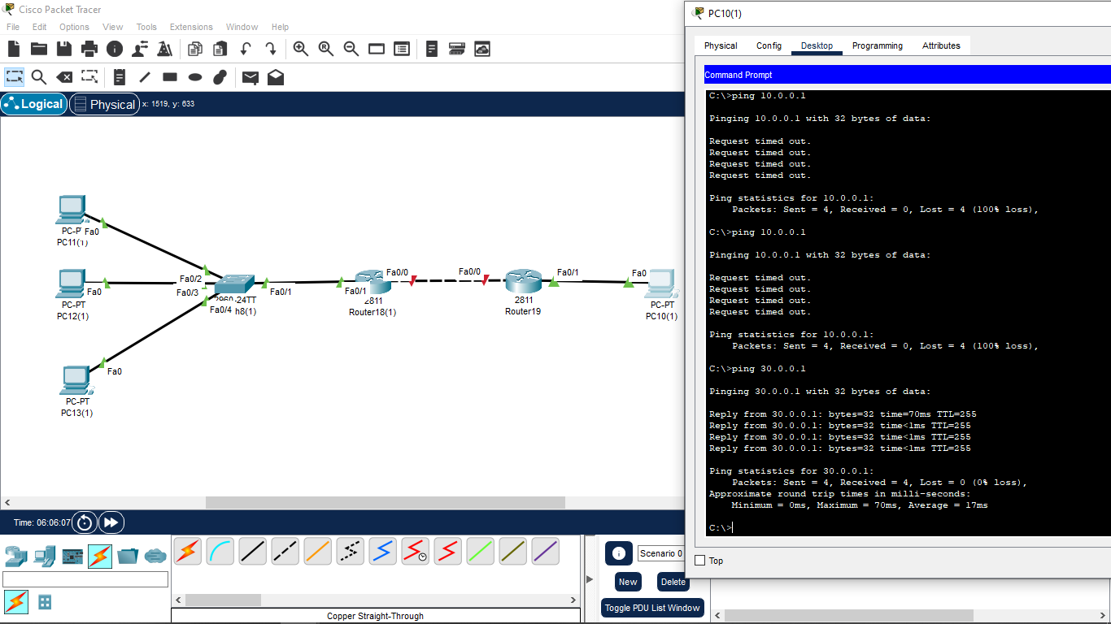

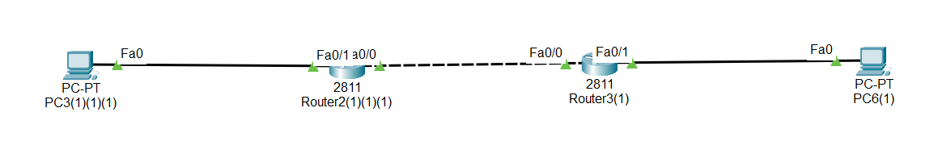

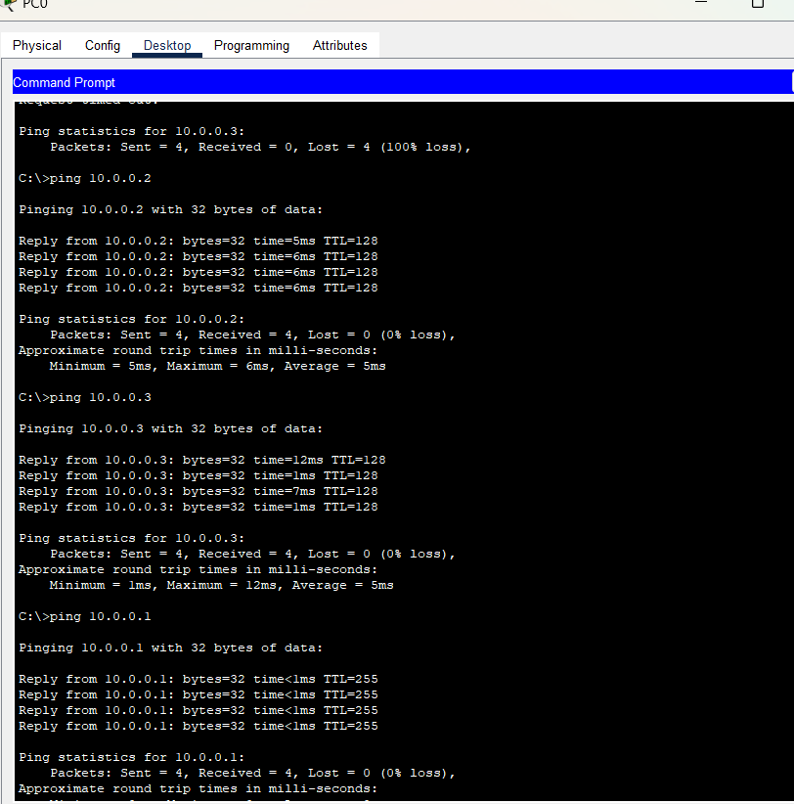



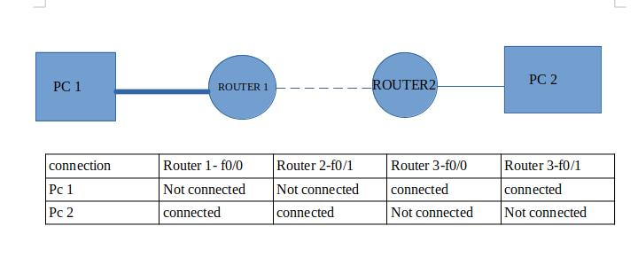

 Static:

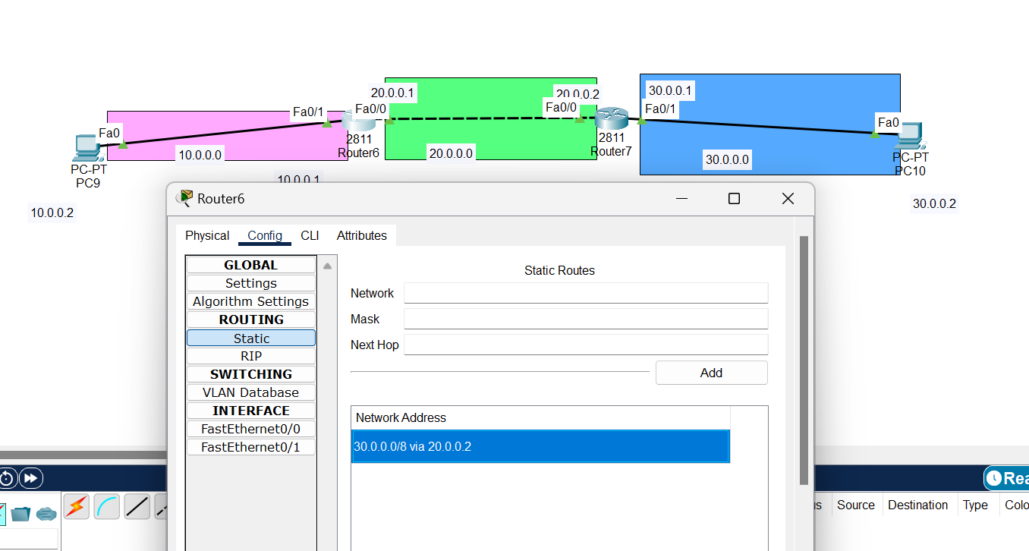

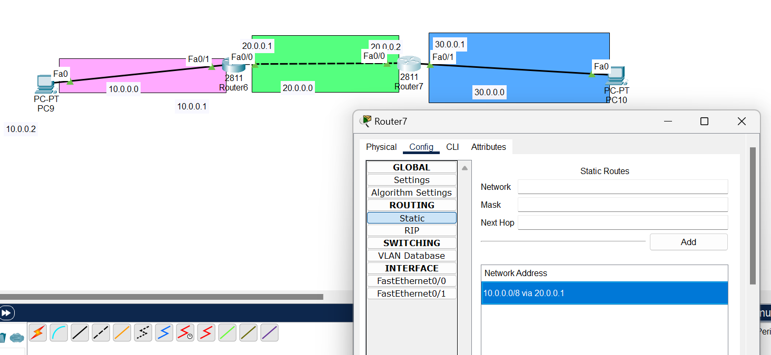

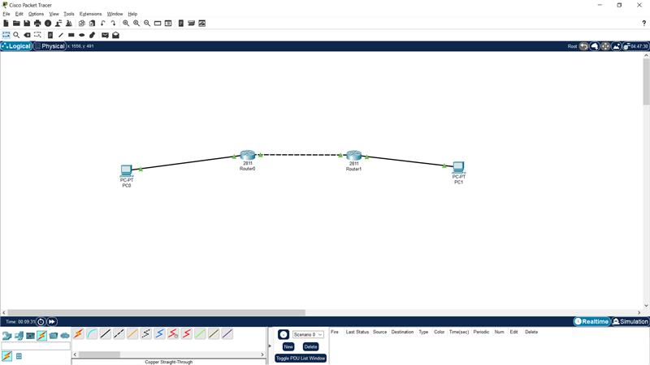

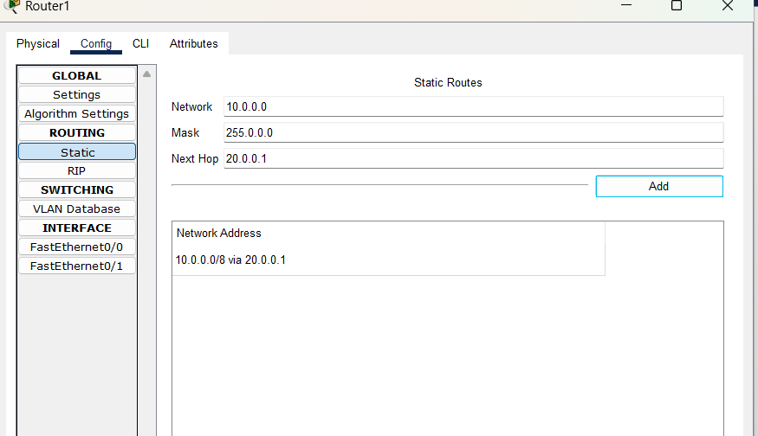

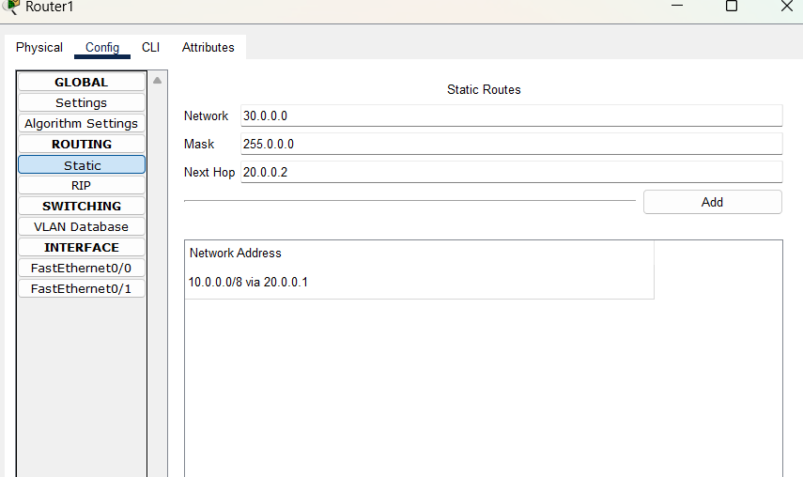

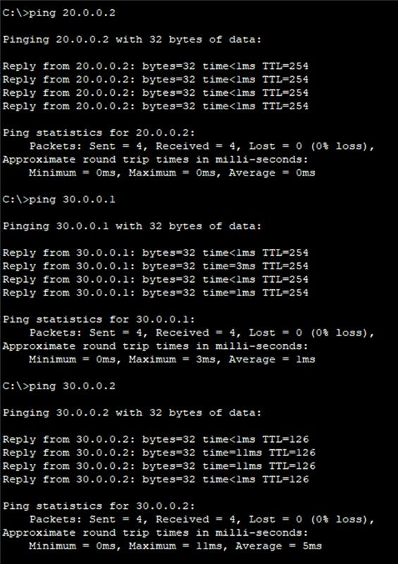

Day:5

OSI Model is a **Open Systems Interconnection**

7 layers

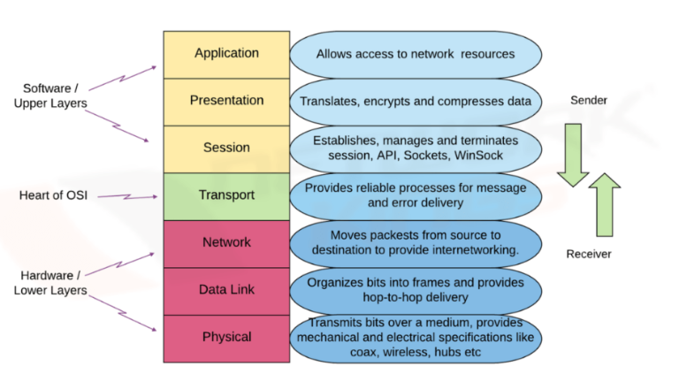

OSI VS TCP/IP

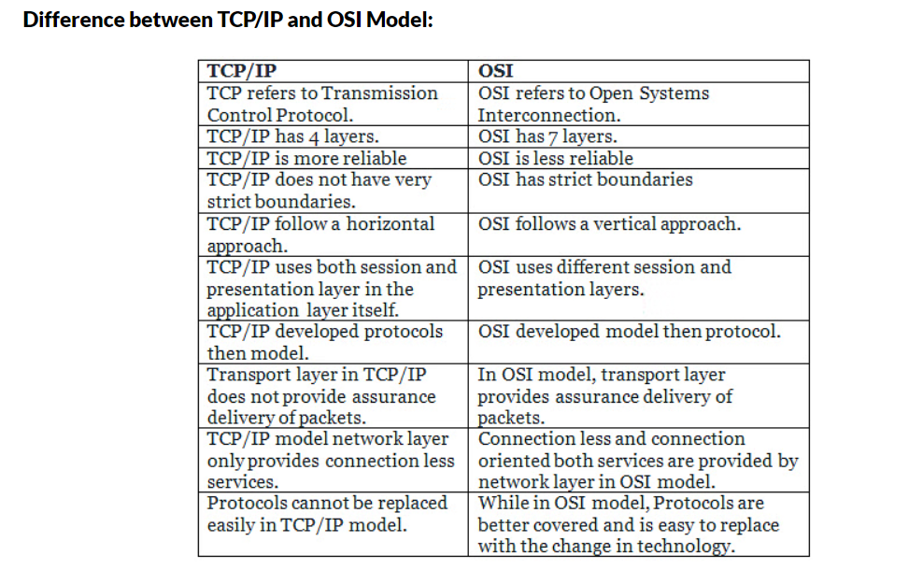

Application Layer (Layer 7)

Function: Provides network services directly to end-users and applications.

Examples:

1. **HTTP (Hypertext Transfer Protocol)** - Port 80

2. **HTTPS (HTTP Secure)** - Port 443

3. **SSH (Secure Shell)** - Port 22

4. **FTP (File Transfer Protocol)** - Port 21

5. **SMTP (Simple Mail Transfer Protocol)** - Port 25

6. **DNS (Domain Name System)** - Port 53

7. **POP3 (Post Office Protocol version 3)** - Port 110

8. **IMAP (Internet Message Access Protocol)** - Port 143

9. **LDAP (Lightweight Directory Access Protocol)** - Port 389

10. **RDP (Remote Desktop Protocol)** - Port 3389

11. **MySQL Database** - Port 3306

12. **HTTP Proxy** - Port 8080

13. **Telnet** - Port 23

14. **SFTP (SSH File Transfer Protocol)** - Port 22

15. **SNMP (Simple Network Management Protocol)** - Port 161

16. **HTTPS Proxy** - Port 3128

17. **NTP (Network Time Protocol)** - Port 123

18. **NetBIOS** - Port 137-139

19. **Microsoft SQL Server** - Port 1433

20. **LDAP Secure (LDAPS)** - Port 636

21. **Kerberos** - Port 88

22. **VNC (Virtual Network Computing)** - Port 5900

23. **SMTP Secure (SMTPS)** - Port 465

24. **Syslog** - Port 514

25. **PostgreSQL Database** - Port 5432

